Project Management Plan

Scope management plan

Project Requirements

Project Functional Requirements
- The program should enable the processing and analysis of large datasets using advanced big data tools and platforms.
- The program should allow stakeholders to access data-driven insights and apply them in decision-making processes.
- The program should enhance workflow efficiency by leveraging big data for process improvements.

Project Non-Functional Requirements
- The program should implement protection protocols to ensure data privacy and secure sensitive information.
- The program should establish training and development programs to enhance employee skills and knowledge in big data practices.

Scope Statement (What)
Enhance Zain Company's use of big data analytics by 30% within the next year by implementing advanced analytical tools that improve decision-making processes, increase operational efficiency by 20% across key departments, and address data privacy concerns for 40% of employees, all while ensuring continuous skill development in big data competencies and maintaining data integrity and security standards at 99.9%.

Objectives (Why)
Your objectives should be covering all project aspects. For example: project productivity, stakeholder satisfaction and expectation, time and financial aspects.
project Objective | project Benifit | Success metric
Enhance the use of big data analytics key departments. | Improved decision-making and operational efficiency. | Increased usage of data-driven insights in decision-making by 30%.
Address data privacy concerns for employees. | Increased trust in data handling and compliance with regulations. | 40% reduction in data privacy concerns reported by employees.
Implement all project phases within a 12-month timeframe. | Timely delivery of project outcomes, ensuring momentum is maintained. | Completion of all milestones within the specified 12-month period.
Manage the project budget efficiently. | Optimized financial resources, ensuring ROI on investments in analytics tools. | Adherence to the project budget with no significant overruns.
Provide targeted training to close the skills gap in big data. | Enhanced employee competencies, leading to more effective data utilization. | Completion of training programs by all relevant employees.

WBS

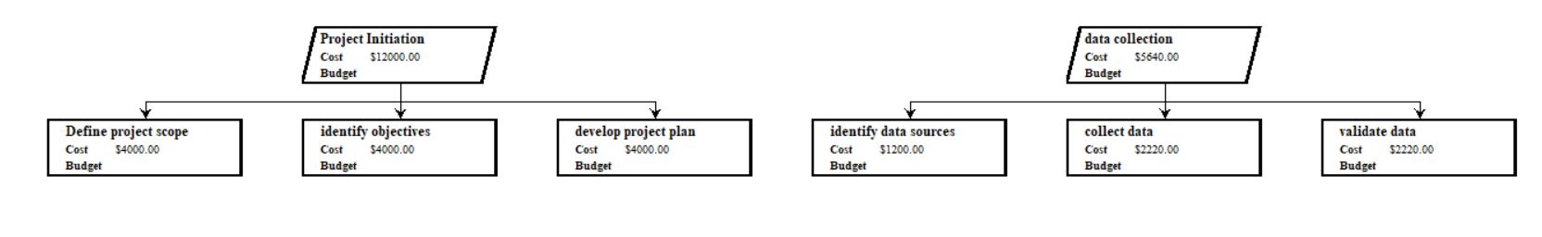
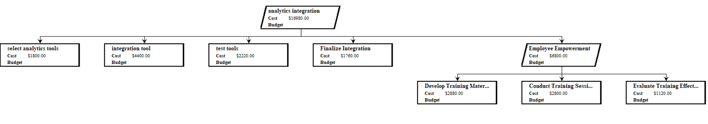
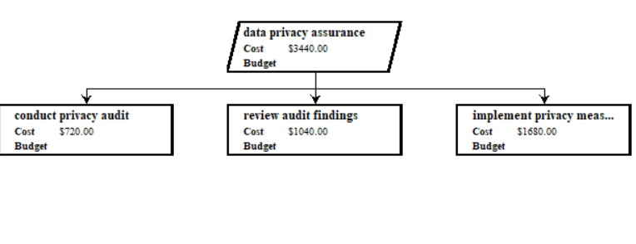

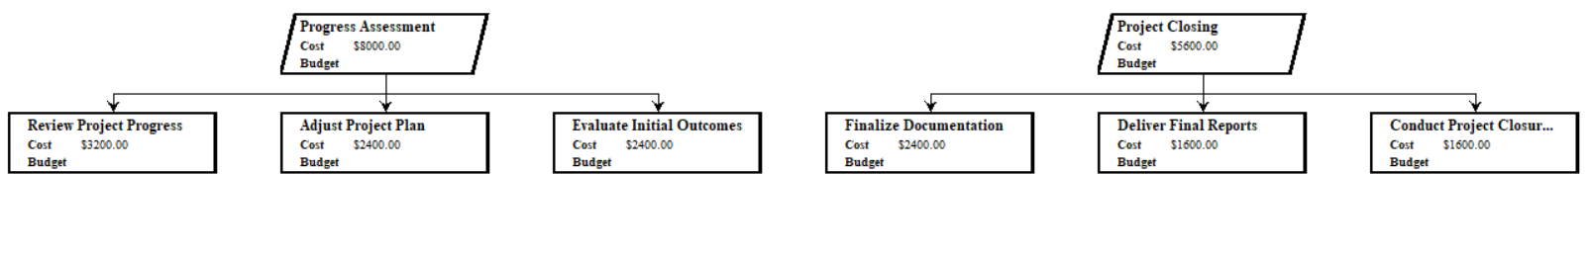

Milestones (When)
Date | Milestone | Description
1-8-2024 | Project Initiation | Project Kickoff: Finalize project scope, objectives, and detailed project plan.
11-8-2024 | Data collecting | Begin collecting data from relevant sources for analysis.
17-8-2024 | Data Privacy Assurance | Completion of Data Privacy Audit: Conduct and review the data privacy audit across departments.
30-8-2024 | Analytics Integration | Implementation of New Analytics Tools: Select and integrate advanced data analytics tools.
11-9-2024 | Employee Empowerment | Training Completion: Complete targeted training sessions for all relevant employees.
24-9-2024 | Progress Assessment | Mid-Project Review: Assess progress, make necessary adjustments, and evaluate initial outcomes.
1-10-2024 | Project closing | Finalize all project activities, deliver final reports, and close the project.

Time, Cost, and Resources Management Plan

Gannt Chart
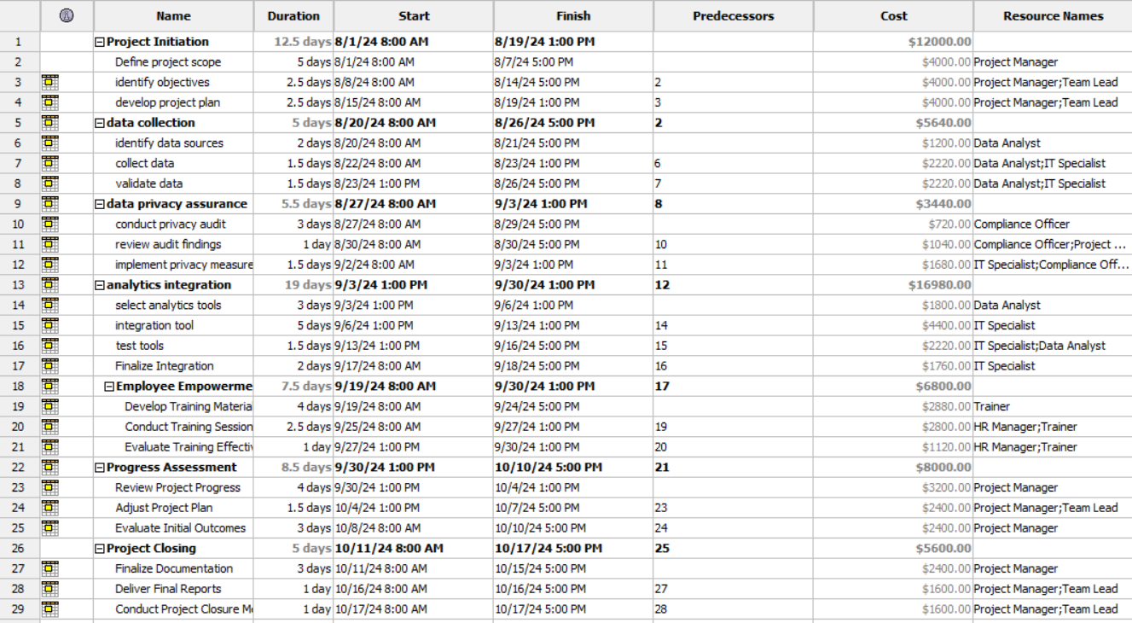
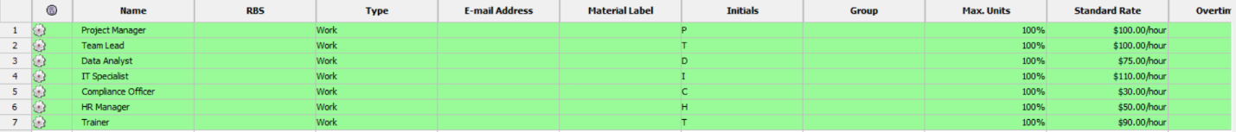
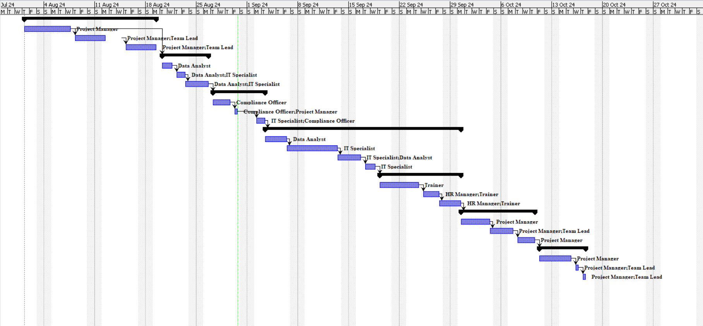

Critical Path Analysis
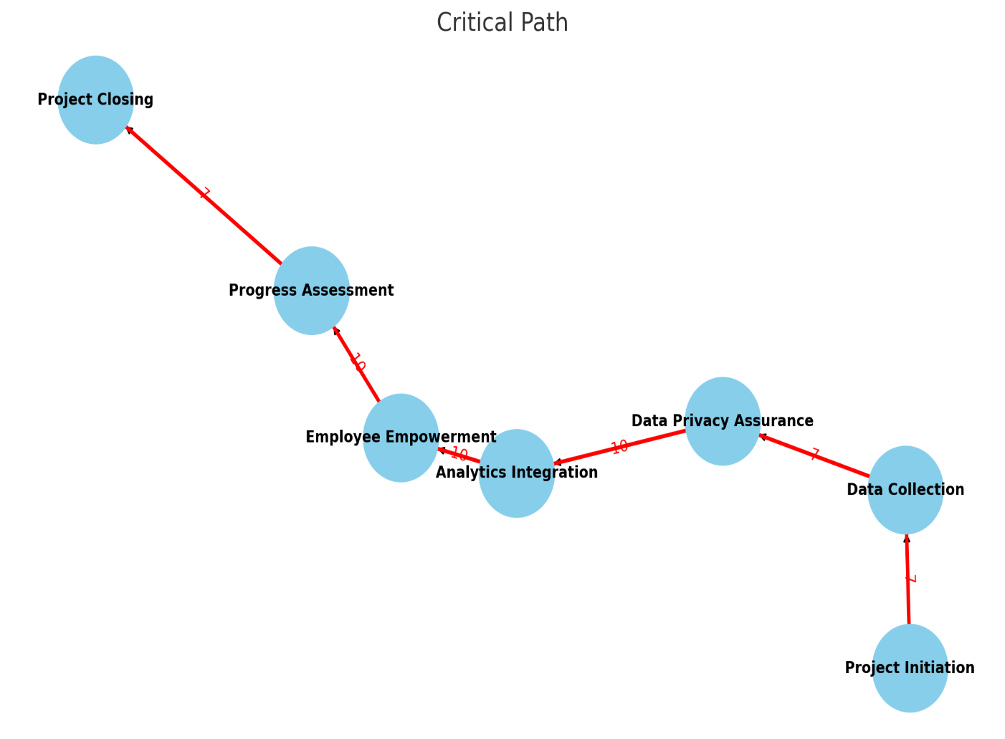

Path 1: Project Initiation (15)→ Data Collection(7) → Data Privacy Assurance(7) → Analytics Integration (10)→ Employee Empowerment(10) → Progress Assessment(10) → Project Closing(7).
Total=66 days

Path 2: Project Initiation(15) → Data Privacy Assurance(7) → Analytics Integration(10) → Employee Empowerment(10) → Progress Assessment(10) → Project Closing(7).
Total=59 days
Path 1 is the Critical Path with a total duration of 66 days.
This path determines the project completion time. Any delay in tasks on this path will delay the entire project.

Produce A Cost Estimate (Budget)
Category | Description | Estimated Cost (JOD)
Personnel Costs
Project Manager | 1 manager for 2.5 months | 12,000
Team Lead | 1 team lead for 2.5 months | 8,000
Data Analysts | 2 analysts for 1 month | 6,120
IT Specialist | 1 specialist for 1 month | 8,200
Compliance Officer | 1 officer for 0.5 month | 3,440
HR Manager | 1 HR manager for 1 month | 3,200
Trainers | 2 trainers for 1 month | 2,800
Software and Tools
Big Data Analytics Tools | Rent for 2 months | 19,680
Data Privacy Tools | Rent for 1 month | 3,440
Training Materials | Materials for employee training | 2,880
Data Acquisition
Data Purchase | External data if needed | 3,440
Data Collection | Collecting and validating data | 5,040
Hardware Costs
Servers/Computers | Purchase | 8,000
Networking Equipment | Routers, switches, etc. | 1,500
Travel Expenses | For meetings or field visits | 1,500
Training and Development
Training Sessions | For staff | 2,000
Workshops/Seminars | Attendance fees | 1,000
Miscellaneous Costs
Travel Expenses | For meetings or field visits | 1,500
Contingency Fund | 10% of total costs | 5,600
Total Estimated Cost |  | 94,840

Personnel Costs: This group shows the salaries that are paid to the main employees of the project and shows the salaries and number of each of them throughout the project period
Software and Tools: These costs include renting tools and programs for analyzing big data, data privacy, and any programs or tools for training, and these tools and programs have the largest role in the implementation of the project.
Data acquisition: represents the costs of obtaining data from external sources (if needed)
Hardware costs: includes costs for the purchase of equipment, servers and network equipment
Training and development: expenses for training sessions and workshops in order to provide and train employees on what they need
Miscellaneous costs: includes travel costs and emergency fund

Change Management Plan

Awareness
- Identify the Target Group:
- Determine the group affected by the change.
- Understand their concerns and fears related to the change.
- Gather Data and Information:
- Collect data on the concerns of the affected group.
- Analyze information to understand their resistance or anxieties.

- Establish Communication Channels:
- Identify the most effective communication methods between change leaders and the affected group.
- Set clear objectives for communication (e.g., reducing anxiety, providing information).
- Clarify the Goal of Communication:
- Specify the purpose of communication (e.g., informing, educating, or reassuring).
- Decide on the type of communication (e.g., meetings, reports, newsletters) and how it will be conducted.
- Clarify the Goal and Timeline of the Change:
- Clearly explain the reasons for the change.
- Provide a detailed time plan for the implementation of the change.
- Highlight the benefits and how the affected group will adapt to the change.
- Maintain Continuous Communication During the Change:
- Keep the affected group informed of ongoing progress and developments.
- Share updates on how the change is unfolding.
- Training and Support After Change:
- Train the affected group on how to work with the new system or process.
- Provide support during the early stages of the post-change period.
- Obtain Feedback After the Change:
- Collect feedback from the affected group to identify areas needing improvement.
- Use feedback to adjust and improve aspects of the change process.
- Final Version and Continued Communication:
- Implement a final version of the change after necessary improvements.
- Continue communicating with the affected group to ensure the change is successful and effective.

Readiness

- Training and Education:
  - Develop comprehensive training programs and practical workshops.
  - Tailor the training process based on specific roles and tasks.
  - Allocate training sessions for each task and job separately, ensuring that each group of employees receives the exact information they need for their roles.
- Launch of a Trial Version:
  - Step 1: Introduce the trial version to a small group of users to quickly identify and correct any errors.
  - Step 2: After initial adjustments, launch a comprehensive trial version for a broader group of users to ensure a smooth transition.
- User Engagement:
  - Involve users early in the process to gather their input and monitor their reactions.
  - Engage users regularly to reduce resistance to change and foster a sense of ownership.
- Continuous Monitoring and Development:
  - Implement ongoing monitoring to identify areas that may need further improvement or additional training.
  - Continuously develop and refine the process to ensure it meets user needs and maintains their confidence throughout the change.

Resilience
1. Pre-start procedures:
Work on a comprehensive system test, including pressure tolerance, safety, and system readiness test for launch
Then identify the problems that were discovered in the testing phase and develop clear plans to avoid minor problems

2. Start and launch the system:
Launching the system at more than one stage and gradually, by providing the system to the groups or users most in need of it, thus reducing pressure on it and allowing modifications to it with the presence of a support team of specialists in order to directly support any user who faced problems or in order to answer any inquiries related to the project or deal with it
With the importance of having a help center ready with a staff ready to deal with an increasing amount of communications

3. Project Monitoring:
After launching the project, it must be kept under surveillance because unexpected errors can occur, considering feedback from users.

4. User Support:
Conducting specialized workshops to clarify the concepts of my apple may be vague (not clearly understood) while providing training for users and this may help close the gaps that may occur, and develop a list of the most frequently asked questions with their answers

5. Change Management:
Help users on how to adapt to change and how to adopt new processes in the system, make sure change managers are on high alert to collaborate, support and encourage users, start planning for updates and developments that will occur in the future

Risk Management Plan

Risk Types

Risk Type | Risk name | Scenario | Mitigation Plan
Data quality problems | R1 | Relying on completely unhealthy and incoherent data to the system, which leads to problems in the decision-making process | Data validation and integrity  Ensure that reliable data sources are used
Resistance to change | R2 | Failure to accept the use of new tools and techniques, which leads to insufficient or ineffective use of them, which leads to failure in the decision-making process | Conducting awareness and training programs for employees  highlighting the importance of dealing with change effectively  Support the use of new tools
Security problems | R3 | Endangering user data or sensitive data | Conducting strict protection protocols and encrypting data Training employees on the basics of data protection
Cost overrun | R4 | The project exceeded the budget set for it due to challenges, risks and developments | Develop an emergency budget  develop a cost controller
Integration problems | R5 | The difficulty of integrating the new system with the work and existing information, which may lead to delays and poor efficiency | Full planning for integration between systems  the use of third-party software to facilitate integration

Probability chart:
 | Probability
 | Risk name | Qualitative | Quantitative (if measurable)
Low | Data Security Breach | This may never happen, but it should be taken into consideration. | At the maximum probability up to 5%
Medium | Integration Challenges | May occur due to difficulty merging | The percentage may be 15%-25%
 | Cost Overruns | Based on the problems and developments that may occur | The percentage is between 30%-40%
High | Resistance to Change | High probability due to difficulty switching | The percentage is between 50%-60%
 | Data Quality Issues | Due to the diversity of data sources may occur severely | The percentage may reach 65%_75%

Impact chart:
Impact
 | Risk name | Impact Description
Low | Integration Challenges | Potential project delays and inefficiencies in the internal processes of the system
Medium | Cost Overruns | Financial problems may be the reason for reducing the project and may lead to reducing the features of the project and may lead to adjusting the project schedule
 | Resistance to Change | Failure to accept change may reduce the return on investment and will affect the productivity of the project
High | Data Quality Issues | Data quality has a sensitive impact on the project, which may lead to errors in the decision-making process, and this leads to poor operational efficiency
 | Data Security Breach | Penetration leads to legal problems and problems in the company's reputation and may lead to a loss of customer confidence in the company, which may affect the company immediately and in the long term

Probability and Impact Matrix:
Probability/Impact Matrix
 |  | Impact
 |  | Low | Medium | High
Probability | High |  | Resistance to Change | Data Quality Issues
 | Medium | Integration Challenges | Cost Overruns
 | Low |  |  | Data Security Breach

Software development methodology
Agile
the Agile project management methodology was chosen due to its flexibility, adaptability and focus on iterative progress. Agile is particularly suitable for projects that involve the integration of new technologies and require constant stakeholder engagement, as is the case with this data analysis project.

Why Agile?
Flexibility and adaptability:

Iterative development: Agile allows iterative development, which means that the project can be divided into smaller, manageable phases or 'races'. This enables the team to continuously assess progress and make necessary adjustments along the way. For example, if a particular data analysis tool does not work as expected, Agile allows the team to quickly shift and explore alternatives without disrupting the entire project.
Responding to change: In a rapidly evolving field such as data science and big data analytics, requirements and goals can change as new insights emerge. Agile flexibility allows the project team to respond to these changes effectively, ensuring that the end results are aligned with the latest needs of the organization.
Stakeholder Engagement:

Constant feedback: Agile emphasizes collaboration and continuous communication with stakeholders. This ensures the participation of stakeholders in the decision-making process throughout the project life cycle. For example, regular reviews and demos allow management, employees, and other key stakeholders to provide feedback on project progress, ensuring their needs are met.
Early and frequent delivery: Agile allows early delivery of functional components of a project, such as a working prototype of a data analytics tool. This not only helps validate the direction of the project, but also provides stakeholders with early value, increasing their engagement and satisfaction.
Risk Management:

Early identification of problems: By breaking down the project into smaller races, Agile allows the team to identify potential risks and address them early in the project. For example, if there are technical challenges associated with integrating a particular tool, they can be identified and resolved in a race before they affect the entire project.
Built-in flexibility: Agile's inherent flexibility means that budget, schedule, and resource allocation risks can be managed more effectively. If the enemy operation is challenged, it is easier to reallocate resources or adjust schedules without major disruptions.
How Agile will be used in the project
Sprint Planning:

The project will be divided into several races, each focusing on a specific set of outcomes. For example, the first race may focus on finalizing the project scope and starting data collection, while subsequent races will focus on integrating analytics tools, conducting training sessions, and reviewing progress.
Each race will have clearly defined objectives, timelines, and outputs, which will be reviewed and adjusted based on feedback from stakeholders.
Daily meetings and race review:

Daily meetings will be held to discuss progress, address any obstacles, and ensure consensus among project team members. This ensures that everyone is on the same page and that any issues are resolved promptly.
At the end of each race, a review of the race will be conducted to show progress and gather feedback from stakeholders. This feedback will be used to improve the approach for the next race.
Integration and continuous testing:

As part of the Agile methodology, integration and continuous testing will be implemented to ensure that each component of

Project Recommendation and Justification

Methods and mediums to communicate with the stakeholders

Stakeholder name | Stakeholder role | Stakeholder type | Methods or mediums | Frequency | Justification
 | employees | Internal | office meetings, internal bulletins | Twice a week | enhance communication and keep employees informed of updates
 | Management | Internal | Meetings, Reports | Weekly | Keep management informed of progress and make it able to make the right decisions
 | Shareholders | External | General Meetings, Quarterly Reports | Annually | Ensure transparency and inform shareholders of the company's performance
 | Customers | External | Social Media, Surveys | Monthly | Improve Customer Satisfaction and Continuous Interaction

Arguments of Planning decisions
1. Cost estimate analysis: The detailed cost report is prepared very carefully in order to calculate all the necessary and basic costs, including
Personnel costs: by allocating a large part of the budget to employees, because it is very important to have highly qualified employees because it is one of the most important reasons for achieving high-quality results

Software and tools: Prioritize investing in tools because of their central importance in the success of the project, because it enables the team to deal with big data smoothly

Emergency Fund: It represents 10% of the total costs, which is considered a safety valve for unexpected things

2.Finished Products:
Scope: Identify clear results considering that they are compatible with the objectives of the project, and this helps in managing trends and developing a clear plan to be followed
Final reports: The final outputs, which can be considered one of the pillars of transparency and accountability, in addition to being a reference for subsequent projects and providing a clear understanding of the project and all its details.

3. Success Metrics:
Measurable metrics: Identify measurable metrics to facilitate an objective assessment of success and whether or not the project performance is attributable

Goal-aligned metrics

4. Impact Analysis:
Stakeholder Impact: Assess how the project will affect stakeholders, which will work to develop clearly and directly affect their performance and thus increase productivity

Problem mitigation: Analyze and study potential problems and risks with the incorporation of clear strategies to deal with them

5. Project Management Methodology:
Agile Methodology:
Flexibility: This is why we chose this methodology because it shares with other methodologies as flexibility, through which it also makes the team able to adapt to any changes that occur during work and since data-related projects are described as complex in nature so one of their most important pillars is iteration.
Major Stakeholder Engagement: This element is given importance in this method as it proves to be a mandatory criterion so that the system will comply with all stakeholders’ needs and expectations.
Gradually Improving: This methodology ensures that you make progress slowly in such a way that the project starts delivering value through your analysis techniques and tools early on before projects completion.
Risk management- This methodology breaks down a project into smaller parts which allows production if required, review and modification reducing risks

Project recommendations

Evaluating Project Recommendations and their Fit with the Organization

Several factors must be considered to see how the project recommendations align with the needs of a chosen organization including budget, timeline, risks involved in tackling them and resources at your disposal along with a well-defined change management plan. Every tiny detail of it is predefined in order to be parallel with the organization’s ambitions, strengths, and future goals.

1. Budget Alignment

Ideal Budget: This is a budget that was thoughtfully created to cover the needs, among other things, and avoid the wants. This encompasses personnel costs, software & tools, data acquisition (or programming), hardware purchase that includes computers and other equipment needed to perform the evaluation(s), training for the evaluators so as they are able to understand how various pieces of technology work and a last but not least-a contingency fund.

Rationalization — The budget sits on top of a decision-making matrix that aligns resources we already own to the things most important outcomes/deliverables required for overall project success. In this way, it also guarantees that the directed amounts of money are to be spent more on people (namely data professionals, IT experts and project managers) rather than software. The higher funding for software and tools highlights the need to have predictive analytics capabilities in addition to complying with data privacy protections.

Fulfilling Organizational Needs: The organization’s needs are met by the budget; all necessary aspects of the project get funded without stretching financial resources. It further protects the project by allowing for financial resilience should issues arise that are not accounted for in advance, thereby reducing potential budget overruns.

2.Timeline Alignment
Timeline: The timeline of the project was built to track through in a structured medium with phases like initiation, data collection, analytics integration, training progress assessment and closure of everything afterwards. All broken down into discrete tasks defined with specific start and stop-date, along with task dependencies between each.
Reasoning: The timeline was created to confirm quick project delivery while their employees were the only ones around that would be able to implement change at work. Making use of buffer time for unforeseen delays, the timeline keeps things moving without sacrificing quality because it builds in realistic deadlines.
Flexibility for Your Organization: The timeline corresponds to the organization’s operational calendar and strategic objectives. It means more tools and practices can be gradually integrated with minimal disruption to ongoing operations. It also acts as a timeline making sure all essential deliverables are created on time for consistent evaluation and possible tweaking.

3.Risk Management
The Known Risks: Some of the potential risks are cost of overruns throughout deployment, late delivery in software production till implementation, absolutely every contest from employees to transfer their off-beat work such as manual card swiping outcomes or shortage will likely take conflicts and technical hurdles in combining new-fangled tools.
Explanation: The project plan includes legitimating attrition by providing a context of preparedness (contingency funds, adaptable approach to project management )Agile(, periodic reviews and retraining). These measures are taken to decrease the effect of risks and lead the project through completion.
Meeting the needs of the company: This factor is a vital one as risk management helps the company run smoothly even when unexpected hurdles come in between. The project recommendations offer the organization a comprehensive approach to mitigating risks as and when they arise.

4.Resource Allocation
Recommended resources: through key roles such as project manager and data analyst through their use of materials and equipment such as programs such as big data analysis programs

Rationale: Resources are allocated based on the needs of each stage of the project, for example, investing in training materials and programs leads to ensuring the readiness of employees in order to benefit as much as possible from the analysis tools

Meeting the needs of the company: Resources are allocated according to the company's needs
In order to build capabilities and competencies in the field of big data analysis while maintaining the operational efficiency of employees, the goal is to ensure the company's readiness to face the challenges it is going through and seize future opportunities.
5. Change Management:
Change approach: The project includes a clear plan for change management, and that plan contains all the details during the change phase, such as methods and methods of communication, stakeholder engagement, and training on integration with change.

Rationale: Change management is crucial, especially when working within a company, so the plan should include clarification of the training sessions, support plan and communication methods in order to address any concerns related to change.
Meeting the company's needs: A change management plan minimizes the risks of resistance to change and ensures that they are ready for transformation, helping to achieve long-term success.

